HALL MANAGEMENT CENTER
Software Engineering | B.Tech 3rd Year, 1st Semester
Department of Computer Science and Engineering
Submitted by
-V.CharanTeja Reddy(R200135)

Team Members:
R.Manju Bhargav(R200158)
G.Sai Lakshmi(R200671)
M.Pushpa(R200660)
S.SaniyaBegum(R201085)

under the guidance of Mr .Ajay
ASSISTANT PROFESSOR DEPARTMENT OF CSE


DEPARTMENT OF COMPUTER SCIENCE AND ENGINEERING

RAJIV GANDHI UNIVERSITY OF KNOWLEDGE TECHNOLOGIES

RK VALLEY,Vempalli(M)
Kadapa(Dist),
Andhra Pradesh(S),516330

Table Of Contents:

CONTENT PAGE NO

SRS DOCUMENT..........................................................................3 - 10

URD DOCUMENT.........................................................................10 – 35

WORK BREAKDOWN..................................................................36

CLASS DIAGRAM.........................................................................37

ER DIAGRAM.................................................................................38

SAMPLE UI’S.................................................................................39 - 41

REQUIREMENT SPECIFICATION DOCUMENT(SRS) for
Hall Management Center(HMC)

Team-12:INNOVATORS

Team Details:

S.NO. | NAME | ID | EMAIL
1. | Gajulapalli Sailakshmi | R200671 | gajulapallisailakshmi@gmail.com
2. | Mandi Pushpa | R200660 | pushpamandi@gmail.com
3. | Shaik Saniya Begum | R201085 | sksaniyabegum2005@gmail.com
4. | Ramisetty Manju Bhargav | R200158 | sanho8142@gmail.com
5. | Vennapusa Charan Teja | R200135 | vctr1912@gmail.com

Table of Contents:

1.Introduction

2.Purpose

3.Intended Audience
3.1.Stakeholders

4.product Vision
4.1.vision statement

5.Technologies

6.System in Context

7.Context Diagram

8.Functional Requirements

9.Non-Functional Requirements
9.1.Performance
9.2.Reliability
9.3.Usability
9.4.Security
9.5.Maintainability

10.Conclusion

1.Introduction:
This document has the requirements of Hall Management Center. The HMC tool is used by Universities. By using the HMC Tool, Universities provide a better facilities for students for their accommodation.

2.Purpose:

The purpose of this document is to gather the requirements that are needed for implementing the Hall Management Center(HMC). It also focuses on various aspects such as scope and visibility of different users ,overview on performance of different users.
The purpose of HMC is to provide efficiency to the universities in maintaining student accommodation and maintain the data of the particular student user up to the date. It provides an online visibility of the status of an user.

3.Intended Audience:

The intended audience will be Hall management administration who want to accommodate students.

3.1.Stakeholders:

Client : Hall Administrator ( Warden )
Users : individuals who use the HMC
(Student , Warden , Mess Manager , Chairman , Staff Manager)

4.Product Vision

4.1Vision Statement:

The product vision is to develop a HMC Tool, which is user friendly and easily accessible. This HMC Tool helps to manage student accommodations.

5.Technologies:
Hardware: Desktop Computers,Barcode Scanners,Printers
Software:
Frontend : HTML , CSS , JAVSCRIPT
Backend : XAMPP , MYSQL , PHP

6.System in Context:

HMC Tool is a multi user system which provides Information about student accommodation. It gets student details from the administration and also accepts queries and provide solutions. It aims to provide basic visibility to give a clarity to the personnel. It provides status of the halls to users, support personnel and administrator. It allows administrator to change the status of current halls.

7.CONTEXT-DIAGRAM:

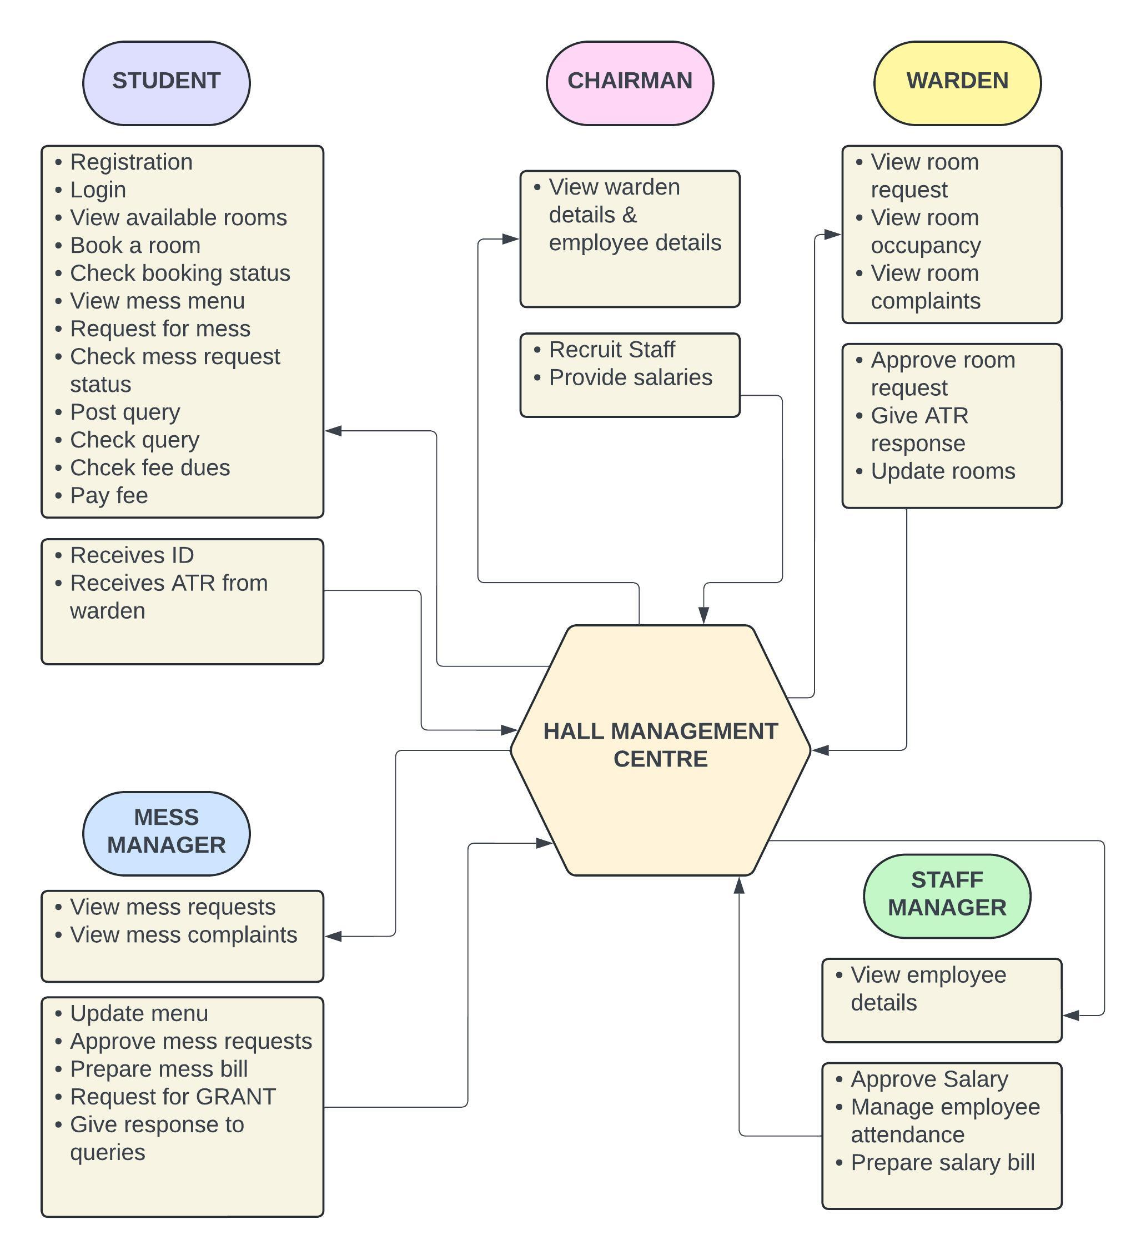

8.Functional Requirements:

- System (Hall Management Center) supports five types of people.
  - Student: Register with the basic details,Registers for rooms and halls,register for mess with selected menu,Raise complaints
  - Warden: validates room requests from student and receives room request,update room and hall details,receives complaints from student and post his ATR to each complaint,views accounts and fees.
  - Mess Manager: prepare food menu with prices,receives the mess details from student,receives and respond to the complaints from student,have visibility on administration about mess fee.
  - Chairman: Have visibility on wardens,Recruitment of staff,Distribution of funds.
  - Staff Manager: Have visibility on all other users,issues salary cheques to staff,maintain attendance details of staff,managing the staff details.
- Student Registers for the functionalities of Hall with the following details:
  - Provides his/her personal details(name,phone number,email,photo,address)
  - Register for room with selected type of room(sharing/single),amenities(reading rooms, play rooms,TV rooms etc).
  - Register for mess with selected mess menu(veg/non-veg) and prices according to them.

- Warden gets room request from student and updates the room and hall details as per student requirement. He updates the room & amenities fee which is added to the fee column of administrator page as accommodation fee.

- Mess manager gets mess registration request from student and updates the mess menu of that personnel. He updates the mess fee details of a personnel which is added to the fee column of administrator page as mess fee.

- Chairman has visibility on all other users, and has manages the recruitment of staff and distribution of funds &grant among different halls.

- Staff manager has visibility on all other users ,validates & updates the details of staff,provides monthly salary cheques to the staff.

9.Non-Functional Requirements

9.1.Performance

• The system should process room booking and viewings within seconds.
• The system should handle up to many concurrent users without performance
degradation.

9.1.2.Reliability

• The system should have an uptime of 99.9%.
• The system should perform daily backups to prevent data loss.

9.1.3.Usability

• The UI should be intuitive and easy to navigate for Hall management staff and members.
• Training material should be provided for first-time users.

9.1.4.Security

• The system should have role-based access control.
• The system should encrypt sensitive member and hall information.

9.1.5.Maintainability

• The system code should be modular and follow coding standards to ensure
maintainability.
• The system should allow easy updates to the book and member databases.
10.Conclusion:
SRS document gives information about functional and non-functional requirements of the Hall Management System.It can be further reviewed and update as per requirement and system performance.

USER REQUIREMENT DOCUMENT(URD)
Hall Management Center(HMC):
Team:Innovators
Table of Contents:
1.Introduction
2.Purpose
3.Intended Audience
3.1.Stakeholders
4.product Vision
5.Technologies
6.System in Context
7.System-wide Requirements(Received)
7.1.Actors
7.1.1.Student
7.1.2.Mess Manager
7.1.3.Warden
7.1.4.Staff Manager
7.1.5.Chairman
7.2.Events
7.2.1.For Student
7.2.2.For Mess Manager
7.2.3.For Warden
7.2.4.For Staff manager
7.2.5.For Chairman
8.System Characteristics
9.Functional Requirements
9.1.Use Case Overview
10.Use Case Diagram
11.Use Case Specifications
13.Conclusion

7.System-Wide Requirements(Recieved):
7.1Actors:
The system interacts with four kinds of users.Each user has own functions to
access with system .The functionalities of users are dependent on each other.
-Student
-Mess Manager
-Warden
-Staff Manager
-chairman

7.1.1.Student:
-Register into HMC and views the details like rooms,mess menu,fee dues

7.1.2.Mess Manager:
-Manages mess contract,updates mess menu,review queries,respond to the queries,prepare mess bill,requests for grant

7.1.3.Warden:
-Manages rooms requests and allotment,update room occupancy,prepare rent bill for the student,reviews complaints

7.1.4.Staff Manager:
-Manages the salary posting for employees,attendence of employees,new employee recuitments

7.1.5.Chairman:
-views the details of the employess,warden and post salaries,accept the requests for grant

7.2.Events:

7.2.1.For Student:

1.Register &Login:
-Registers into HMC account and logins whenever needed.

2.View Available room:
-access and view the room occupancy and available rooms.

3.Book A Room:
-books the unoccupied room

4.Check Boking Status:
-checks whether the room is booked or not

5.View Mess Menu,Check Requests
-views the mess menu and checks mess requests

6.Post Query and Check Status
-posts queries about mess and halls

7.Check Fees,Pay Fees
-check the pay dues and fees and completes the dues

8.Recieve ID and ATR
-Recieves ID after registration and Complaint ATR

7.2.2.For Mess Manager:

1.View Mess Requets&Complaints:
-Views the mess requets and complaints posted by student

2.Update Menu:
-Updates the mess menu as per schedule

3.Approve Mess Requests:
-Approves the mess requests from the Students

4.Prepare Mess Bill:
-Prepares pay bill for each individual student

5.Request For Grant:
-Post his Requests about annual grant

6.Post Response for Queries:
-Post Responses for the queries

7.2.3.For Staff Manager:

1.View Employee Details:
-views the employee details like warden and mess manager

2.Approve Salary:
-Approves Salary for the employees

3.Manage Employee Attendance:
-manages Employee attendance on daily basis

4.Prepare Salary Bill:
-Prepares Salary Bill based on overall salary approves

7.2.4.For Warden:

1.View Room Request:
-Views the room request from student

2.View Room occupancy&Complaints:
-Views the room occupancy and reviews the complaints

3.Approve Room Request & Give ATR response:
-Approve the room request from the student and provides response ATR for complaints

4.Update Room details:
-Update the room details based on occupancy

7.2.5.For ChairMan:

1.View Warden Details:
-View the Warden Details

2.View Employee Details:
-Views the Employee Details

3.Recruit Staff:
-Recurit the new Staff

4.Post Salaries :
-Post Salary for the employees

8.System Characteristics:

 | Actor | Action | Object | Frequency | Arrival  Pattern | Response
1. | Student | Register &  login | Account | Once per user | User registers a single account & login when needed | Confirmation page for account creation and login page to login.
2. | Student | View available rooms | HMC database | Moderate | As needed,to find suitable rooms | presented with a list of available rooms and their details.
3. | Student | Book a room | Booking | Moderate | Once per Semester or as needed | Room is booked for the specified period
4. | Student | Check booking status | HMC Database | Moderate | As needed,to track booking status | presented with the current status of their booking.
5. | Student | View mess menu | Menu | Frequent | As needed ,to plan meals | presented with the mess menu and can view or make requests.
6. | Student | Post query  & check status | Queries | Moderate | As needed,to report issues or request assistance | submits a query and can track its status.
7. | Student | Check dues & Pay dues | Dues | Moderate | When the due time arrives | outstanding dues are displayed,payment record is updated.
8. | Student | Recieve ID and ATR | ID and ATR | Low | Only when ID is allloted and ATR is Recieved | ID and ATR are available for view,records the retrieval of the documents by the student.
9. | Mess Manager | View Mess Requests & Complaints | Requests&  Complaints | High | Needs to look into it to find neww requests and complaints | viewed the pending mess requests and complaints.
10. | Mess Manager | Update Menu | Menu | High | Mess menu need to be updated based on requests | menu is updated.
11. | Mess Manager | Approve Mess Requests | Requets | High | Always need to check and approve mess requests | either approved or rejected
12. | Mess Manager | Prepare Mess Bill | Bill | Moderate | Only required when the time for mess billing arrives | The monthly mess bill is generated.
13. | Mess  Manager | Request for Grant | Grants | Moderate | Requesting grant is only possible during some durations | posts a request to the chairman about grant.
14. | Mess  Manager | Post response for Queries | Response | Moderate | Only when the student post queries | reponses are generated.
15. | Staff Manager | View Employee Details | Employee | Moderate | As needed,when the new staff joins or salary has to be provided | viewed the desired employee details.
16. | Staff Manager | Approve Salary | Salary | Monthly | Typically at the end of each period | salary has been approved for payment.
17. | Staff Manager | Manage Employee Attendence | Attendence | Daily | Daily,especially during peak attendance tracking periods | Employee attendance records have been updated.
18. | Staff Manager | Prepare Salary Bill | Bill | Monthly | Monthly,typically at the end of each pay period | The salary bill is generated and ready for review.
19. | Warden | View Room requests | Room | High | As needed,because student room preferences may change frequently | viewed the room request details.
20. | Warden | View Room Occupancy & Compliants | Room Database | Moderate | Only starting of the semester or durations | viewed the room occupancy and complaint details
21. | Warden | Approve Room Request & ATR | Requetss | High | As needed,when the students post room requests and when he needed to request for ATR | approved or rejected, and the student has received an ATR response.
22. | Warden | Update room details | Room | Low | Less frequent,Only when a new room is alloted or vacated | The room details have been updated
23. | Chairman | View Warden Details | Warden | Low | Less frequent,only when grants need to be provided | viewed the warden's details.
24. | Chairman | View Employee Details | Employee | Low | Less frequent ,only when salaries are to be granted | viewed the employee's details.
25. | Chairman | Recruit Staff | Staff | Low | Very less,only in the starting of the duration | New staff members have been recruited.
26. | Chairman | Post Salary | Salary | Moderate | Mostly monthly or according due pay period | Salaries have been provided to the staff members

9.Functional Requirements:

9.1.Use case Over view:

 | Use case ID | Use Case Name | Priority | Stability | Verifiability
1. | UC-HMC-R&L | Register & Login | High | Stable | Verifiable
2. | UC-HMC-VAR | View Avaiable Room | High | Stable | Verifiable
3. | UC-HMC-BAR | Book A Room | High | Stable | Verifiable
4. | UC-HMC-CBS | Check Booking Status | High | Stable | Verifiable
5. | UC-HMC-VMR,CMR | View Mess Menu,Check Requests | High | Stable | Verifiable
6. | UC-HMC-PQ &CQS | Post Query and Check Status | High | Stable | Verifiable
7. | UC-HMC-CF,PF | Check Fees,Pay Fees | High | Stable | Verifiable
8. | UC-HMC-RID&ATR | Recieve ID and ATR | High | Stable | Verifiable
9. | UC-HMC-VMR&C | View Mess Requets&Complaints | High | Stable | Verifiable
10. | UC-HMC-UM | Update Menu | High | Stable | Verifiable
11. | UC-HMC-AMR | Approve Mess Requests | High | Stable | Verifiable
12. | UC-HMC-PMB | Prepare Mess Bill | High | Stable | Verifiable
13. | UC-HMC-RG | Request For Grant | High | Stable | Verifiable
14. | UC-HMC-PRQ | Post Response for Queries | High | Stable | Verifiable
15. | UC-HMC-VED | View Employee Details | High | Stable | Verifiable
16. | UC-HMC-AS | Approve Salary | High | Stable | Verifiable
17. | UC-HMC-MEA | Manage Employee Attendance | High | Stable | Verifiable
18. | UC-HMC-PSB | Prepare Salary Bill | High | Stable | Verifiable
19. | UC-HMC-VRR | View Room Request | High | Stable | Verifiable
20. | UC-HMC-VRO&C | View Room Occupancy&Complaints | High | Stable | Verifiable
21. | UC-HMC-ARR&GAR | Approve Room Request&Give ATR Response | High | Stable | Verifiable
22. | UC-HMC-URD | Update Room Details | High | Stable | Verifiable
23. | UC-HMC-VWD | View Warden Details | High | Stable | Verifiable
24. | UC-HMC-VED | View Employee Details | High | Stable | Verifiable
25. | UC-HMC-RS | Recruit Staff | High | Stable | Verifiable
26. | UC-HMC-PS | Post Salaries | High | Stable | Verifiable

10.Use Case Diagram:
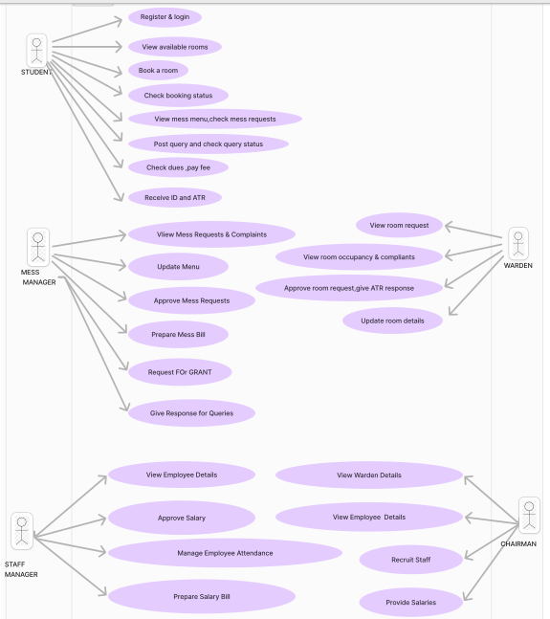

11.USE CASE SPECIFICATIONS:
1.UC-HMC-R&L:Register and Login
Use-Case ID :  UC-HMC-R&L | Use-case Name : Register & Login
Description | The student registers for an account with the Hall Management System and logs in to access available features.
Pre-Conditions | Student does not have an existing account.
Post-Conditions | Student successfully creates an account and logs in.
Frequency of Use | Once per user.
Main Success Scenario  (or basic flow) | Student provides personal information for registration.  The system verifies the information and creates an account.  Student logs in using their credentials.
Extensions  (or alternate flows) | If information is incorrect or incomplete, the system prompts the student to correct it. If the login attempt fails due to incorrect credentials, the system displays an error message.
Frequency of Occurrence | Once per user initially, followed by frequent logins.
2.UC-HMC-VAR:View Available Rooms

Use-Case ID : UC-HMC-VAR | Use-case Name : View Available Room
Description | The student views the list of available rooms in the hall.
Pre-Conditions | Student is logged in.
Post-Conditions | Student is presented with a list of available rooms and their details.
Frequency of Use | As needed, to find suitable rooms.
Main Success Scenario | Student navigates to the "Rooms" section.  The system displays a list of available rooms with details like room type, capacity, and amenities.
Extensions | No alternate flow.
Frequency of Occurrence | Frequent, especially during the room booking process.

3.UC-HMC-BAR:Book A Room

Use-Case ID : UC-HMC-BAR | Use-case Name : Book A Room
Description | The student books a room for a specific period.
Pre-Conditions | Student is logged in and a room is available.
Post-Conditions | Room is booked for the specified period.
Frequency of Use | Once per semester or as needed.
Main Success Scenario  (or basic flow) | Student selects a room from the available list. Student chooses a start date and end date for the booking. The system verifies availability and confirms the booking. Student receives a booking confirmation.
Extensions  (or alternate flows) | If the room is not available, the system displays an error message. If the booking details are invalid, the system prompts for correction.
Frequency of Occurrence | Once per semester or as needed.

4.UC-HMC-CBS:Check Booking Status

Use-Case ID : UC-HMC-CBS | Use-case Name : Check Booking Status
Description | The student checks the status of their room booking.
Pre-Conditions | Student is logged in and has a booking.
Post-Conditions | Student is presented with the current status of their booking.
Frequency of Use | As needed, to track booking status.
Main Success Scenario  (or basic flow) | Student navigates to the "Bookings" section.  The system displays the current status of the booking (e.g., confirmed, pending, cancelled).
Extensions  (or alternate flows) | No alternate flow.
Frequency of Occurrence | Frequent, especially after booking a room.

5.UC-HMC-VMR,CMR:View Mess Menu,Check Mess Requests

Use-Case ID :  UC-HMC-VMR,CMR | Use-case Name :View Mess Menu, Check Mess Requests
Description | The student views the mess menu and checks or makes mess requests
Pre-Conditions | Student is logged in.
Post-Conditions | Student is presented with the mess menu and can view or make requests.
Frequency of Use | As needed, to plan meals.
Main Success Scenario  (or basic flow) | Student navigates to the "Mess" section.  The system displays the current mess menu. Student can view or make requests for specific dishes or dietary needs.
Extensions  (or alternate flows) | No alternate flow.
Frequency of Occurrence | Frequent, especially during meal planning.

6.UC-HMC-PQ & CQS : Post Query and Check Query Status
Use-Case ID : UC-HMC-PQ&CQS | Use-case Name : Post Query and Check Query Status
Description | Post Query and Check Query Status
Pre-Conditions | Student is logged in.
Post-Conditions | Student submits a query and can track its status.
Frequency of Use | As needed, to report issues or request assistance.
Main Success Scenario  (or basic flow) | Student navigates to the "Queries" section.  Student submits a query or request.  The system assigns a query ID and displays the query status.  Student can track the query status
Extensions  (or alternate flows) | If the query is invalid or incomplete, the system prompts for correction. If the query is resolved, the system updates.
Frequency of Occurrence | As needed, to report issues or request assistance.

7.UC-HMC-CF,PF:CheckFees , Pay Fees

Use-Case ID : UC-HMC-CF,PF | Use-case Name : Check Fees, Pay Fees
Description | This use case allows a student to check their outstanding dues and pay them through the system.
Pre-Conditions | The student is logged into the system. The system has an active internet connection.
Post-Conditions | The student's outstanding dues are displayed. The student's payment record is updated.
Frequency of Use | Moderate
Main Success Scenario  (or basic flow) | The student selects the "Check Fees" option. The system displays the student's outstanding dues. The student selects the "Pay Fees" option. The system prompts the student to choose their payment method.The student enters their payment details and confirms the payment.The system processes the payment and updates the student's fee record. The system displays a confirmation message.
Extensions  (or alternate flows) | Payment Error: If there is an error processing the payment, the system displays an error message and prompts the student to try again.  Insufficient Funds: If the student's payment account has insufficient funds, the system displays an error message and prompts the student to use a different payment method.
Frequency of Occurrence | Moderately high

8.UC-HMC-RID&ATR:Recieve ID and ATR:

Use-Case ID : UC-HMC-RID&ATR | Use-case Name : Receive ID and ATR
Description | This use case allows a student to receive their student ID and ATR (Attendance Tracking Record) digitally.
Pre-Conditions | The student is logged into the system. The student's profile has been created.
Post-Conditions | The student's ID and ATR are available for download/view. The system records the retrieval of the documents by the student.
Frequency of Use | Low
Main Success Scenario  (or basic flow) | The student selects the "Receive ID and ATR" option.  The system retrieves the student's ID and ATR from the database. The system displays the student's ID and ATR in a printable format. The student has the option to download or print their ID and ATR.
Extensions  (or alternate flows) | Document Retrieval Error: If there is an error retrieving the documents, the system displays an error message and prompts the student to try again.
Frequency of Occurrence | Low

9.UC-HMC-VMR&C:View Mess Requests & Complaints
Use-Case ID : UC-HMC-VMR&C | Use-case Name : View Mess Requests & Complaints
Description | The Mess Manager can view all pending mess requests and complaints from students.
Pre-Conditions | The Mess Manager is logged in.
Post-Conditions | The Mess Manager has viewed the pending mess requests and complaints.
Frequency of Use | High
Main Success Scenario  (or basic flow) | The Mess Manager selects the "View Mess Requests & Complaints" option from the menu.  The system displays a list of all pending mess requests and complaints.  The Mess Manager reviews the requests and complaints.
Extensions  (or alternate flows) | If there are no pending requests or complaints, the system displays a message indicating this.
Frequency of Occurrence | High

10.UC-HMC-UM:Update Menu

Use-Case ID : UC-HMC-UM | Use-case Name : Update Menu
Description | The Mess Manager updates the daily mess menu based on availability and feedback.
Pre-Conditions | The Mess Manager is logged in.
Post-Conditions | The mess menu is updated.
Frequency of Use | High
Main Success Scenario  (or basic flow) | The Mess Manager selects the "Update Menu" option from the menu. The system displays the current mess menu.  The Mess Manager makes any necessary changes to the menu. The Mess Manager saves the changes.
Extensions  (or alternate flows) | If the Mess Manager does not make any changes, the system displays a confirmation message.
Frequency of Occurrence | High

11.UC-HMC-AMR:Approve Mess Requests

Use-Case ID : UC-HMC-AMR | Use-case Name : Approve Mess Requests
Description | The Mess Manager approves or rejects mess requests from students.
Pre-Conditions | The Mess Manager is logged in.
Post-Conditions | The mess request is either approved or rejected.
Frequency of Use | High
Main Success Scenario  (or basic flow) | The Mess Manager selects the "Approve Mess Requests" option from the menu.  The system displays a list of pending mess requests.  The Mess Manager reviews each request and either approves or rejects it.
Extensions  (or alternate flows) | If the Mess Manager needs further information before approving or rejecting a request, they can contact the student for clarification.
Frequency of Occurrence | Moderate

12.UC-HMC-PMB:Prepare Mess Bill

Use-Case ID : UC-HMC-PMB | Use-case Name : Prepare Mess Bill
Description | The Mess Manager prepares the monthly bill for mess charges.
Pre-Conditions | The Mess Manager is logged in.
Post-Conditions | The monthly mess bill is generated.
Frequency of Use | Moderate
Main Success Scenario  (or basic flow) | The Mess Manager selects the " Prepare Mess Bill" option from the menu. The system generates the monthly mess bill based on student usage. The Mess Manager reviews the bill for accuracy.
Extensions  (or alternate flows) | If there are any errors in the bill, the Mess Manager can correct them and regenerate the bill.
Frequency of Occurrence | Moderate

13.UC-HMC-RG:Request For Grant

Use-Case ID : UC-HMC-RG | Use-case Name : Request For Grant
Description | The Mess Manager Requets the Annual grant from the chairman.
Pre-Conditions | The Mess Manager is logged in.
Post-Conditions | The mess manager posts a request to the chairman about grant.
Frequency of Use | Moderate
Main Success Scenario  (or basic flow) | The Mess Manager selects the "Request for grant" option from the menu. The system displays the current status of requesting status. The Mess Manager Requests for grant if the request portal is ready to accept the request.
Extensions  (or alternate flows) | If the Request is accepted by the chairman the system gives notification to mess manager.
Frequency of Occurrence | Moderate

14.UC-HMC-PRQ:Post Response for Queries

Use-Case ID : UC-HMC-PRQ | Use-case Name : Response For Queries
Description | The Mess Manager Views the Queries and post his responses to each and every query.
Pre-Conditions | The Mess Manager is logged in.
Post-Conditions | The mess manager reponses are generated.
Frequency of Use | Moderate
Main Success Scenario  (or basic flow) | The Mess Manager selects the "View Queries" option from the menu. The system generates the queries based on student problems and questions. The Mess Manager reviews the queries and post his responses to it.
Extensions  (or alternate flows) | If the Responses are not satisfied with the problem mess manager is again notified with another query.
Frequency of Occurrence | Moderate

15.UC-HMC-VED:View Employee Details
Use-Case ID : UC-HMC-VED | Use-case Name : View Employee Details
Description | The Staff Manager can view detailed information about each employee in the hall. This includes their name, contact information, role, and other relevant details.
Pre-Conditions | The Staff Manager is logged into the system and has the necessary permissions to access employee data.
Post-Conditions | The Staff Manager has viewed the desired employee details.
Frequency of Use | Moderate
Main Success Scenario  (or basic flow) | The Staff Manager logs into the system.  The Staff Manager navigates to the "Employee" section.  The Staff Manager selects an employee from the list.  The system displays the employee's details.
Extensions  (or alternate flows) | The Staff Manager enters incorrect credentials. The system displays an error message.
Frequency of Occurrence | High

16.UC-HMC-AS:Approve Salary

Use-Case ID : UC-HMC-AS | Use-case Name : Approve Salary
Description | The Staff Manager approves the calculated salary for an employee.
Pre-Conditions | The Staff Manager is logged in.The employee's salary has been calculated and submitted for approval.
Post-Conditions | The employee's salary has been approved for payment.
Frequency of Use | Monthly, typically at the end of each pay period.
Main Success Scenario  (or basic flow) | The Staff Manager selects "Approve Salary" from the system menu.  - The system displays a list of pending salary approvals.  - The Staff Manager selects the employee whose salary needs approval.  - The system displays the employee's salary details, including the calculated amount and any deductions.  - The Staff Manager reviews the information and clicks "Approve Salary" if the details are correct.  - The system approves the salary and updates the employee's payroll record.
Extensions  (or alternate flows) | If the Staff Manager identifies an error in the calculated salary, they can click "Reject Salary" and provide a reason for rejection.  The rejected salary is sent back to the payroll department for correction.
Frequency of Occurrence | Moderate

17.UC-HMC-MEA:Manage Employee Attendance

Use-Case ID : UC-HMC-MEA | Use-case Name : Manage Employee Attendance
Description | The Staff Manager can track and manage the attendance of employees, including recording absences, leave requests, and other attendance-related events.
Pre-Conditions | The Staff Manager is logged into the system and has the necessary permissions to manage employee attendance.
Post-Conditions | Employee attendance records have been updated.
Frequency of Use | Daily, especially during peak attendance tracking periods.
Main Success Scenario  (or basic flow) | The Staff Manager selects "Manage Employee Attendance" from the system menu.  The system displays a list of employees and their attendance records.  The Staff Manager selects an employee to update their attendance record.  The system displays the employee's attendance details, including dates, hours worked, and absences.  The Staff Manager updates the attendance record as needed, including marking absences or approving leave requests.
Extensions  (or alternate flows) | The Staff Manager encounters a discrepancy in the attendance records.  The Staff Manager investigates and resolves the issue.
Frequency of Occurrence | High

18.UC-HMC-PSB:Prepare Salary Bill

Use-Case ID : UC-HMC-PSB | Use-case Name :Prepare Salary Bill
Description | The Staff Manager prepares the salary bill for a specific pay period, including calculating salaries, deductions, and generating reports.
Pre-Conditions | The Staff Manager is logged in.Employee salary data is up-to-date.The payroll system is configured.
Post-Conditions | The salary bill is generated and ready for review.
Frequency of Use | Monthly, typically at the end of each pay period.
Main Success Scenario  (or basic flow) | The Staff Manager selects "Prepare Salary Bill" from the system menu.  The system prompts the Staff Manager to select the pay period and employee group.  The Staff Manager enters the requested information.  The system calculates salaries, deductions, and generates the salary bill.  The Staff Manager reviews the salary bill and makes any necessary adjustments.
Extensions  (or alternate flows) | If the Staff Manager identifies errors in the salary bill, they can correct the errors and re-generate the bill.
Frequency of Occurrence | Medium

19.UC-HMC-VRR:View Room Request

Use-Case ID : UC-HMC-VRR | Use-case Name :View Room Request
Description | The Warden views requests from students to book a room.
Pre-Conditions | The Warden has logged in to the system.
Post-Conditions | The Warden has viewed the room request details.
Frequency of Use | High
Main Success Scenario  (or basic flow) | The Warden selects the "View Room Request" option.  The system displays a list of pending room requests.  The Warden selects a specific request to view details.
Extensions  (or alternate flows) | If there are no pending room requests, the system displays a message indicating this.
Frequency of Occurrence | High

20.UC-HMC-VRO&C:View Room Occupancy &Complaints

Use-Case ID :  UC-HMC-VRO&C | Use-case Name :View Room Occupancy & Complaints
Description | The Warden views the occupancy status of rooms and any complaints related to them.
Pre-Conditions | The Warden has logged in to the system.
Post-Conditions | The Warden has viewed the room occupancy and complaint details
Frequency of Use | Moderate
Main Success Scenario  (or basic flow) | The Warden selects the "View Room Occupancy & Complaints" option.The system displays a list of rooms and their occupancy status.The Warden can click on a specific room to view complaints related to it.
Extensions  (or alternate flows) | If there are no complaints, the system displays a message indicating this.
Frequency of Occurrence | Moderate

21.UC-HMC-ARR&GAR:Approve Room Request&Give ATR Response

Use-Case ID : UC-HMC-ARR&GAR | Use-case Name :Approve Room Request, Give ATR Response
Description | The Warden approves room requests and provides an Automated Teller Response (ATR) response to the student.
Pre-Conditions | The Warden has logged in to the system and is reviewing a room request.
Post-Conditions | The room request has been approved or rejected, and the student has received an ATR response.
Frequency of Use | High
Main Success Scenario  (or basic flow) | The Warden selects the "Approve Room Request" option.  The system displays the room request details.The Warden approves or rejects the request.The system generates and sends an ATR response to the student.
Extensions  (or alternate flows) | If the Warden needs to request additional information from the student, they can send a message through the system.
Frequency of Occurrence | High

22.UC-HMC-URD:Update Room Details

Use-Case ID : UC-HMC-URD | Use-case Name :Update Room Details
Description | The Warden updates room details, such as availability.
Pre-Conditions | The Warden has logged in to the system.
Post-Conditions | The room details have been updated.
Frequency of Use | Low
Main Success Scenario  (or basic flow) | The Warden selects the "Update Room Details" option.The system displays the current room details.The Warden updates the room details.
Extensions  (or alternate flows) | If the Warden attempts to update room details without the necessary permissions, the system displays an error message.
Frequency of Occurrence | Low

23.UC-HMC-VWD:View Warden Details

Use-Case ID : UC-HMC-VWD | Use-case Name : View Warden Details
Description | The chairman views the details of the warden, such as their name, contact information, and responsibilities.
Pre-Conditions | The chairman has logged in to the system.
Post-Conditions | The chairman has viewed the warden's details.
Frequency of Use | As needed
Main Success Scenario  (or basic flow) | The chairman selects the "View Warden Details" option from the menu. The system displays the warden's details.
Extensions  (or alternate flows) | If the system is unable to retrieve the warden's details, an error message is displayed.
Frequency of Occurrence | Low

24.UC-HMC-VED:View Employee Details

Use-Case ID : UC-HMC-VED | Use-case Name : View Employee Details
Description | The chairman views the details of the employees, such as their name, contact information, and job role.
Pre-Conditions | The chairman has logged in to the system.
Post-Conditions | The chairman has viewed the employee's details.
Frequency of Use | As needed
Main Success Scenario  (or basic flow) | The chairman selects the "View Employee Details" option from the menu. The system displays the employee's details.
Extensions  (or alternate flows) | If the system is unable to retrieve the employee's details, an error message is displayed.
Frequency of Occurrence | Low

25.UC-HMC-RS:Recruit Staff

Use-Case ID : UC-HMC-RS | Use-case Name : Recruit Staff
Description | The chairman recruits new staff members for the hall.
Pre-Conditions | The chairman has logged in to the system.
Post-Conditions | New staff members have been recruited.
Frequency of Use | As needed
Main Success Scenario  (or basic flow) | The chairman selects the "Recruit Staff" option from the menu.  The system displays a form for entering the details of the new staff members. The chairman enters the details of the new staff members and submits the form. The system adds the new staff members to the database.
Extensions  (or alternate flows) | If the system is unable to add the new staff members to the database, an error message is displayed.
Frequency of Occurrence | Low

26.UC-HMC-PS:Post Salaries

Use-Case ID : UC-HMC-PS | Use-case Name : Post Salaries
Description | The chairman provides salaries to the staff members.
Pre-Conditions | The chairman has logged in to the system.
Post-Conditions | Salaries have been provided to the staff members.
Frequency of Use | Moderate
Main Success Scenario  (or basic flow) | The chairman selects the "Provide Salaries" option from the menu.  The system displays a form for entering the salary details.  The chairman enters the salary details and submits the form.  The system updates the salary details in the database.
Extensions  (or alternate flows) | If the system is unable to update the salary details in the database, an error message is displayed.
Frequency of Occurrence | Moderate

WORK-BREAK DOWN :
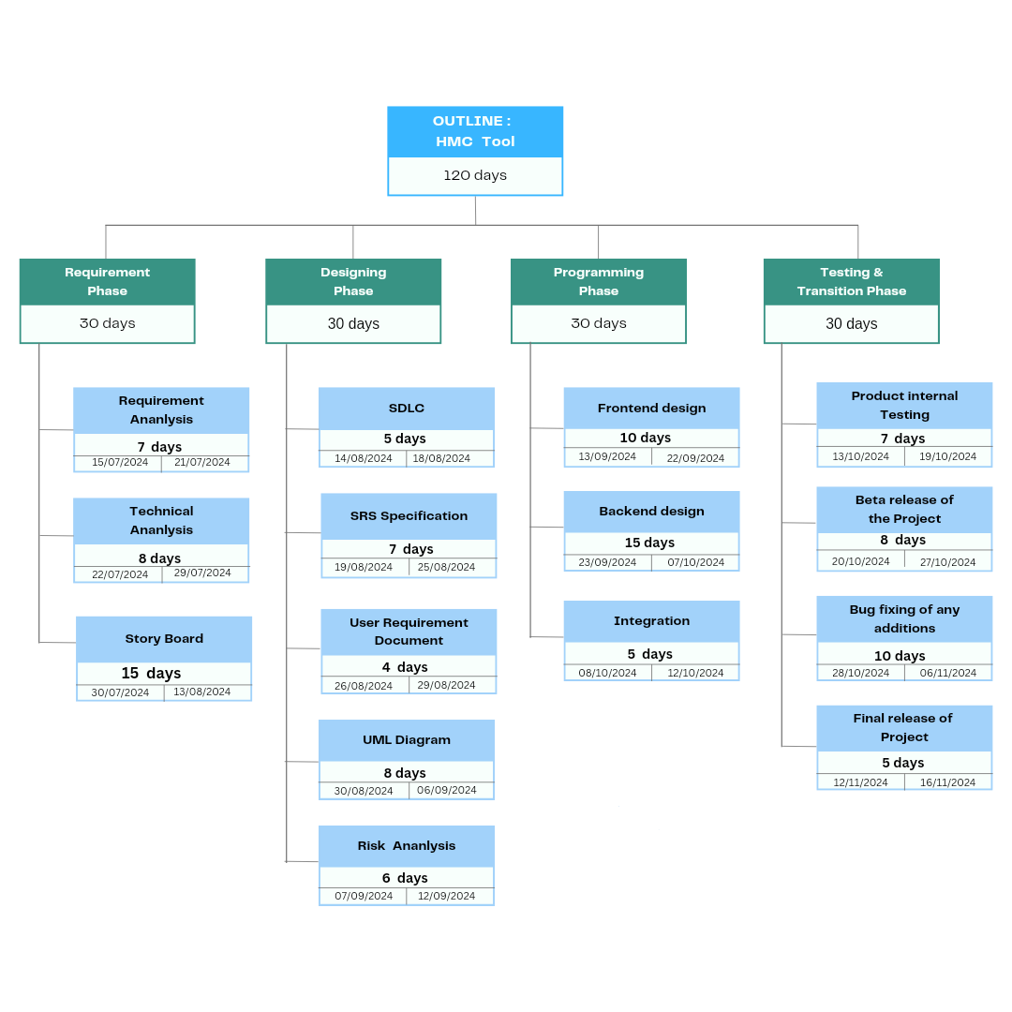

CLASS DIAGRAM:
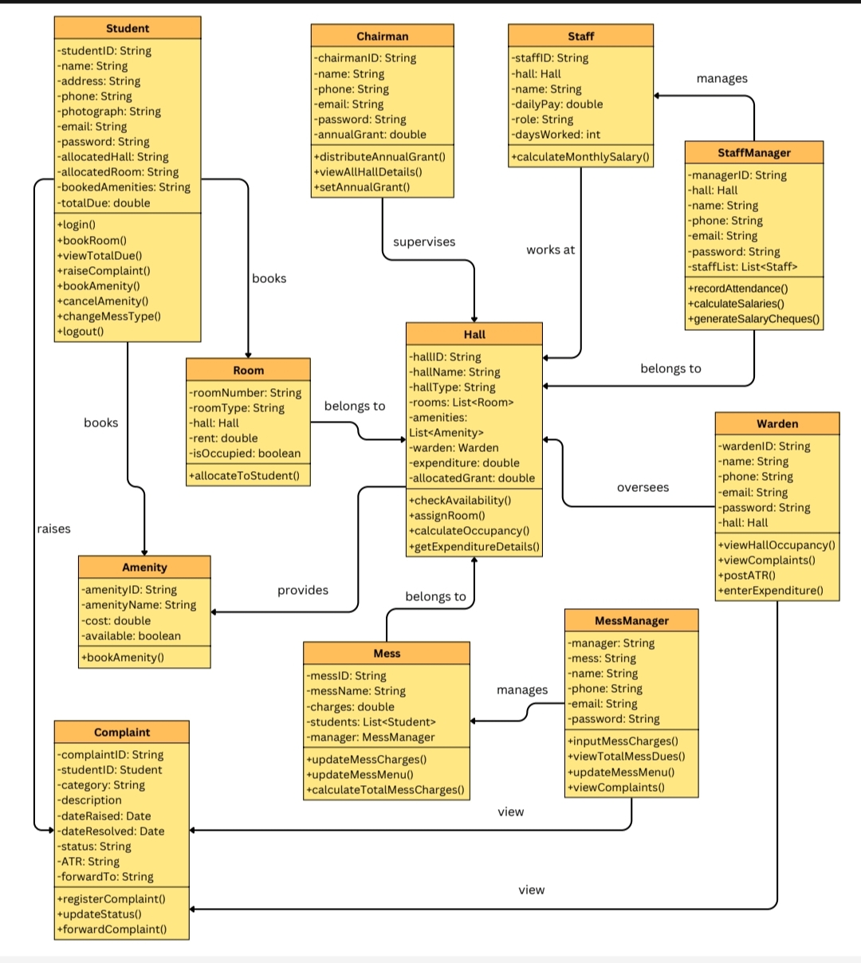

ER DIAGRAM:

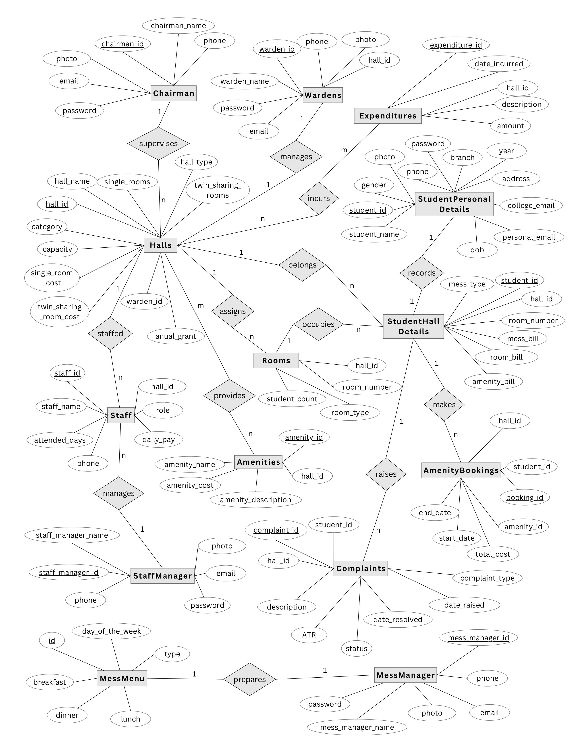

SAMPLE UI’s:
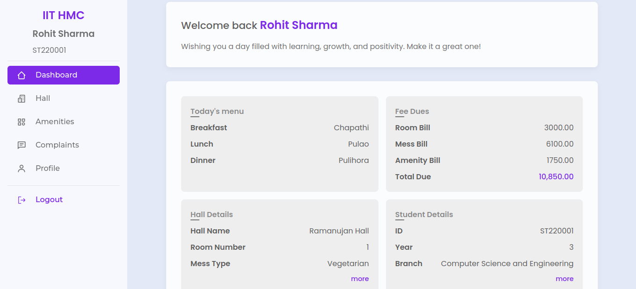

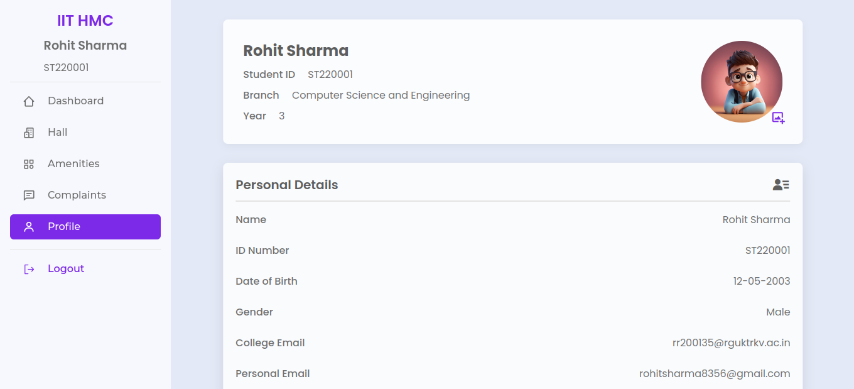

SAMPLE UI’s:
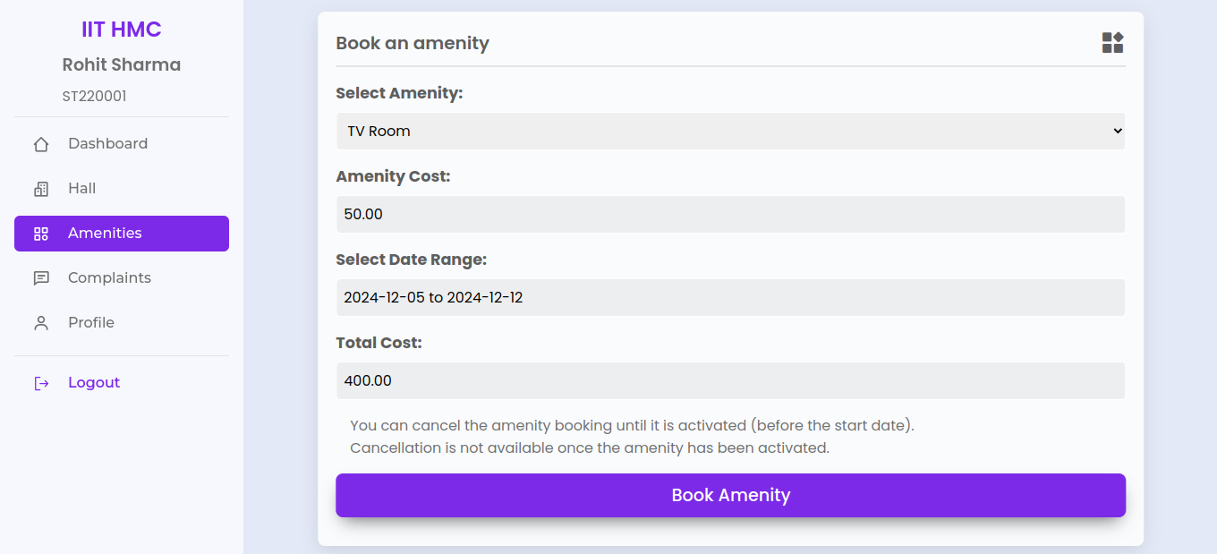

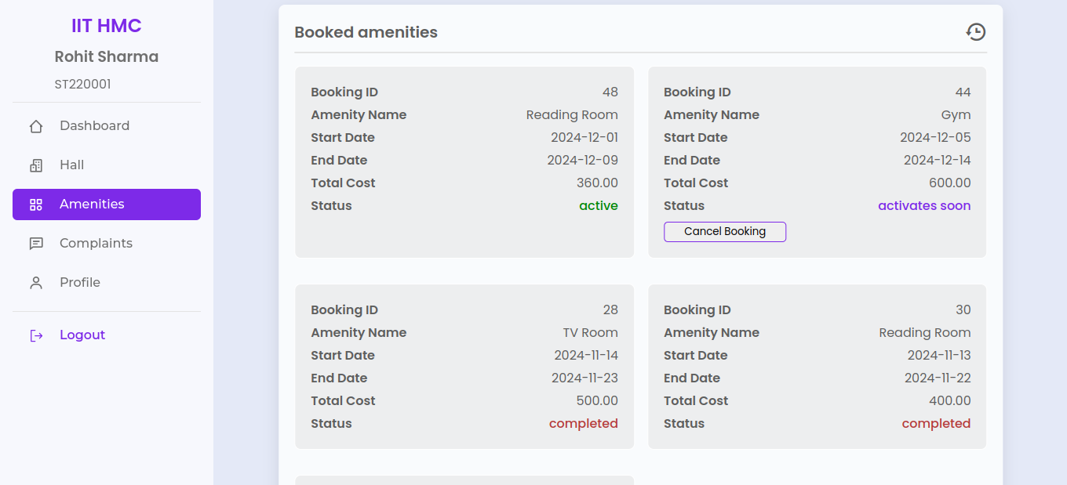

SAMPLE UI’s:

